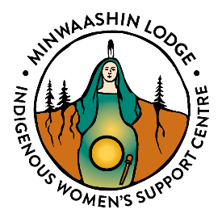
Women’s Gathering 2024 ~ Friday, June 7 to Sunday June 9
Location: Rideau Hill Camp, 3560 Rideau River Rd. Manotick ON K4M 1B4
REGISTRATION FORM
Name

Street Address

Home or Cell #

Email Address

Emergency Contact
And Phone No.

Cabins have 8 bunk beds. If you would like to share a cabin with someone, write their name here_______________________________
(please note we cannot guarantee you will be in the same cabin)
I will be sleeping in a cabin YES NO Can you sleep in an upper bunk _______
I will be camping YES NO I will be sleeping at home.
Will you be taking the free charter bus from Minwaashin. YES NO
We regret that the bus and campsite are not wheelchair accessible.
I would like to request a subsidy I am able to contribute $________
I am sending an electronic payment of $125 to donations@minlodge.com with message: WG2024.
I am enclosing a cheque for $125. I will pay upon arrival
Saturday June 8 only: $40. _____
Please make cheques payable to Minwaashin Lodge – Indigenous Women’s Support Centre. Please email this form to ctroy@minlodge.com or mail to: Minwaashin Lodge 2323 St. Laurent Blvd. Ottawa ON, K1G 4J8
Upon receipt of your Registration Form, you will receive confirmation of your registration along with a complete information package.

